FINAL LAB PROJECT REPORT
NoteNest
An Android Notes and Notes Marketplace Application

Details | Information
Submitted by | Faria Akter Promo
Student ID / Roll | 48
Batch | 85(D)
Department | Computer Science and Engineering
Course Name | Mobile application and Development
Course Code | 0613-410
Submitted to | Ekramul Haque Amin
Institution | Dhaka International University
Submission Date | 7.11.26

Technology: Java, XML layouts, Firebase Authentication and Cloud Firestore

1. Introduction
NoteNest is an Android application concept that combines personal note management with a small marketplace for sharing study notes. It is designed to help students keep useful notes in one place and discover learning materials shared by other users. Users can sign in, create or edit notes, browse public notes, and try a demonstration purchase flow.

1.1 Problem Statement
Students often store study materials in notebooks, text files, messaging applications, and screenshots. This makes it difficult to organize content, find a topic quickly, and share useful materials with classmates. A dedicated app can make note management and discovery more convenient.

1.2 Aim and Objectives
The aim is to develop a simple Android application for managing notes and demonstrating a basic notes marketplace using a cloud backend.
- Provide email-and-password sign-in.
- Allow users to create, edit, save, and view notes.
- Display public notes for browsing.
- Demonstrate a sample purchase record without real payment processing.
- Share note information through Android's sharing interface.
- Store note and purchase data in Cloud Firestore.

1.3 Project Scope
This report describes an MVP. Real payment processing, seller payouts, full PDF upload/download, and production-level marketplace security are outside the stated scope.

2. Application Overview

2.1 Intended Users
The intended users are students and learners who want to organize personal notes or browse study materials shared by others.

2.2 Main User Workflow
- Launch the app and open the login screen.
- Sign in using Firebase Authentication.
- Open the main screen and browse notes.
- Create a new note or edit an existing note.
- Save note information to Firestore.
- Browse public marketplace notes.
- Use the demo purchase action to create a sample record.
- Share note details using the Android share chooser.

2.3 Application Architecture
The app follows a simple Activity-based Android structure. Java classes handle screen logic and Firebase operations, while XML files define the user interface. Firebase Authentication manages sign-in. Cloud Firestore stores note and purchase documents. The Note model represents note data, and NoteAdapter connects note data to the list UI.

2.4 Main Project Classes
File / Class | Purpose
LoginActivity | Login and authentication screen.
MainActivity | Main screen and note browsing.
AddEditNoteActivity | Create and edit notes.
Note | Java model for note data.
NoteAdapter | Displays note items in a list.
XML layout files | Define screen appearance.
AndroidManifest.xml | Declares app components and configuration.

3. Features and Screenshots
The following screenshot panels are placeholders. Add actual screenshots captured from the running app or Android Studio emulator. Do not submit the placeholders as real evidence.

3.1 User Login
The login screen accepts an email address and password. Firebase Authentication handles the sign-in process. The app requires the matching Firebase project configuration.
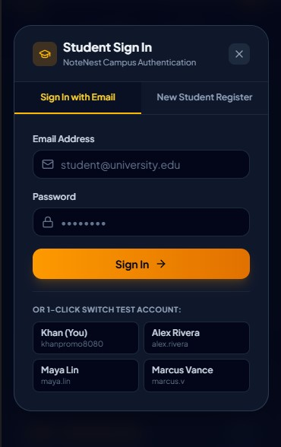
Insert a screenshot showing the login fields. Hide any real password.

3.2 Main Screen and Note Browsing
The main screen is the central place from which a signed-in user can access available notes and app actions.
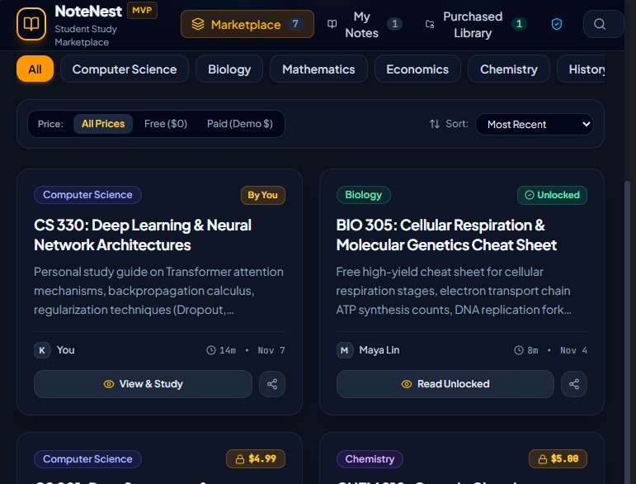
Insert a screenshot showing the note list or marketplace view.

3. Features and Screenshots (continued)

3.3 Add and Edit Notes
Users can enter note information and save it. Existing notes can be opened and edited. The Note model represents note information and Firestore stores the note records.
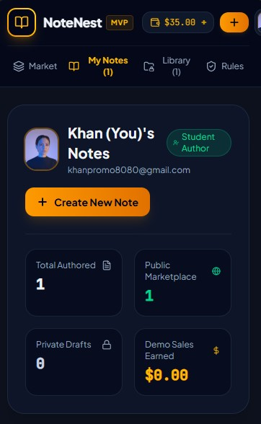
Insert a screenshot of the note entry form.

4. Components Used, Alternatives and Reasons
This is the main technical section. The table lists the core components identified in the NoteNest MVP. Do not list proposed future features as implemented components.
Component Used | Purpose in NoteNest | Alternatives | Reason for Selection
Java | Implements screen logic, note operations, and Firebase interaction. | Kotlin, Dart/Flutter, JavaScript. | Java is supported by Android Studio and is suitable for learning Android programming. It matches the Java-based project approach.
XML Layouts | Defines the login, main, and add/edit screen designs. | Jetpack Compose, programmatic UI. | XML separates interface design from Java logic and makes screen elements easy to arrange and edit.
Activities | LoginActivity, MainActivity, and AddEditNoteActivity represent app screens. | Fragments + Navigation Component, single-Activity architecture. | Activities provide a simple screen structure for a small MVP. Each major task has a clear entry point.
Firebase Authentication | Manages email-and-password sign-in. | Google Sign-In, phone OTP, custom server authentication. | Firebase avoids building password management from scratch and integrates with the Firebase project.

4. Components Used (continued)
Component Used | Purpose in NoteNest | Alternatives | Reason for Selection
Cloud Firestore | Stores note documents and demo purchase records. | Firebase Realtime Database, SQLite, Room, MySQL. | Firestore provides cloud document storage and integrates with Firebase Authentication. It avoids maintaining a separate server.
Note Model Class | Represents the fields and data of a note in Java. | Map<String,Object>, Kotlin data class, database entity. | A model groups note-related values in one structure. It improves readability and separates data from screen code.
NoteAdapter / List Adapter | Connects note data to the list interface and displays each item. | ListView + ArrayAdapter, GridView, Compose LazyColumn. | A dedicated adapter separates item rendering from Activity logic and keeps note display consistent.
Android Intent / Sharesheet | Opens Android's share chooser to share note details. | Copy-to-clipboard, custom share screen, app-specific sharing. | The built-in sharing interface is familiar and supports compatible apps without creating a separate sharing service.
AndroidManifest.xml | Declares Activities and app configuration. | No direct replacement; required Android project file. | Android requires a manifest to identify app components and essential configuration.
Gradle / Firebase Configuration | Manages dependencies and connects the app module to Firebase. | Other build systems, manual library setup. | Gradle is the standard Android build system. Firebase configuration connects the app with the selected Firebase project.

5. Firebase Database Structure
The MVP uses Cloud Firestore. Two logical collections are identified: notes and purchases. Firestore stores documents inside collections. The exact field names must be verified against the final Java code and Firebase Console.

5.1 Notes Collection
Logical Field | Purpose
documentId | Unique Firestore document identifier.
title | Title of the note.
description / content | Text or description of the note.
ownerId | Creator's Firebase UID, if stored.
price | Demo listing price or free/paid indicator, if present.
isPublic | Whether the note is shown publicly, if present.
createdAt / updatedAt | Creation or update time, if stored.

5.2 Purchases Collection
Logical Field | Purpose
documentId | Unique purchase record identifier.
noteId | Reference to the purchased note.
buyerId | Buyer's Firebase UID, if stored.
price | Demo price associated with the note.
status | Demo purchase status, if present.
createdAt | Purchase record time, if stored.

5.3 Simplified Firestore Structure
Collection | Example Documents
notes | note_001, note_002, note_003, ...
purchases | purchase_001, purchase_002, ...

These are logical field descriptions, not a claim that every optional field already exists. Confirm exact keys in the Note model or Firestore Console.

5. Firebase Integration and Data Flow

5.4 Authentication Flow
The user enters an email address and password. The app sends the request to Firebase Authentication. If authentication succeeds, the user can continue to the main screen. If it fails, an error message should be displayed. Plain-text passwords should never be stored in Firestore.

5.5 Note Data Flow
When a user creates or edits a note, the screen collects the note information. Java prepares a Note object or equivalent data map and writes it to the notes collection. The main screen reads relevant note documents and passes them to NoteAdapter for display.

5.6 Demo Purchase Flow
When a user selects the demo purchase action, the app records a sample entry in the purchases collection. This demonstrates database storage but does not verify a financial transaction. A production marketplace needs trusted payment processing and server-side verification.

5.7 Security Considerations
- Use Firebase Authentication to identify signed-in users.
- Never place private credentials or service-account keys inside the Android app.
- Configure Firestore Security Rules to restrict who can read and modify records.
- Do not use client-side demo logic to grant real paid access.
- Test rules with authorized and unauthorized users before publishing.

6. GitHub Repository and Version Control

6.1 GitHub Link
GitHub repository URL: https://github.com/fariapromo
The actual repository URL was not provided. Do not submit an invented link. Copy the URL from GitHub after pushing the final Android Studio project.

6.2 Suggested Repository Contents
- app/ — Android source code and XML layouts.
- build.gradle.kts and settings.gradle.kts — project configuration.
- README.md — project overview and setup instructions.
- .gitignore — excludes generated build files and local machine files.
- Firestore rules reference file, if included.

6.3 Basic Git Workflow
- Create a repository on GitHub.
- Initialize Git in the Android Studio project or use Android Studio Git integration.
- Review files before committing; do not upload passwords or private keys.
- Commit with a clear message such as 'Initial NoteNest MVP'.
- Add the GitHub repository as remote and push the main branch.
- Commit and push later changes so the repository matches the final submission.

6.4 Why GitHub is Useful
GitHub stores source code remotely, keeps a history of changes, and makes it easier to share a project with an instructor or teammates. Git can also help developers compare versions and recover earlier code.

7. Problems Faced and How They Were Solved
Problem / Challenge | Solution or Handling
Android Studio setup and Gradle synchronization | The project was opened from the extracted project folder and Gradle synchronization was allowed to complete. A successful Gradle build was reported.
Firebase connection | The app needs a Firebase project and its matching google-services.json in the app module. Authentication and Firestore must be enabled in Firebase Console.
Understanding project files | The project was organized into the app module, Gradle files, manifest, Java source, and XML layouts. Each Activity has a clear responsibility.
Displaying note data | The Note model and NoteAdapter separate note data from the code that displays it.
Marketplace purchase testing | A demo purchase record is used for demonstration and is clearly distinguished from real payment processing.
Running the app on an emulator | Create and start an Android Virtual Device from Device Manager. A compatible physical Android phone can be used if the emulator is slow.

7.1 Current Limitations
- Real payment processing is not implemented; purchase behaviour is for demonstration only.
- PDF upload and download are not included in the described MVP.
- A successful Gradle build is not the same as complete runtime testing.
- Firestore rules must be reviewed before real users or paid content are involved.
- Actual screenshots and the GitHub URL must be added by the student.

8. Testing, Conclusion and References

8.1 Basic Test Checklist
Test ID | Test Action | Expected Result
TC-01 | Open the application. | Login screen appears.
TC-02 | Sign in with valid Firebase credentials. | User can reach the main screen.
TC-03 | Enter note details and save. | Note is stored and appears in the list.
TC-04 | Edit an existing note. | Updated note information is displayed.
TC-05 | Browse public notes. | Available public notes are displayed.
TC-06 | Select demo purchase. | A sample purchase record is created; no money is charged.
TC-07 | Tap share. | Android share chooser appears.

8.2 Conclusion
NoteNest demonstrates how an Android application can combine personal note management with a basic notes marketplace. It uses Java and XML for the Android interface, Firebase Authentication for sign-in, and Cloud Firestore for cloud data. The Activity structure, Note model, and NoteAdapter organize the project into understandable parts. Demo purchase and Android sharing provide examples of mobile application workflows.
The project is a learning MVP, not a production marketplace. Future improvements may include secure PDF storage and download, search and category filters, user profiles, stronger Firestore rules, verified payment integration, and more complete device testing. Final submission should include real screenshots, exact course details, and the actual GitHub URL.

8.3 References
- Android Developers. Android fundamentals and app components. https://developer.android.com/
- Android Developers. Activities and lifecycle. https://developer.android.com/guide/components/activities
- Firebase Documentation. Authentication for Android. https://firebase.google.com/docs/auth/android/start
- Firebase Documentation. Cloud Firestore. https://firebase.google.com/docs/firestore
- GitHub Docs. Repositories and Git basics. https://docs.github.com/
- NoteNest MVP project source files and configuration.

